QUESTION 7:

CREDIT CARD PROCESSING SYSTEM:

COLLABRATION DIAGRAM:

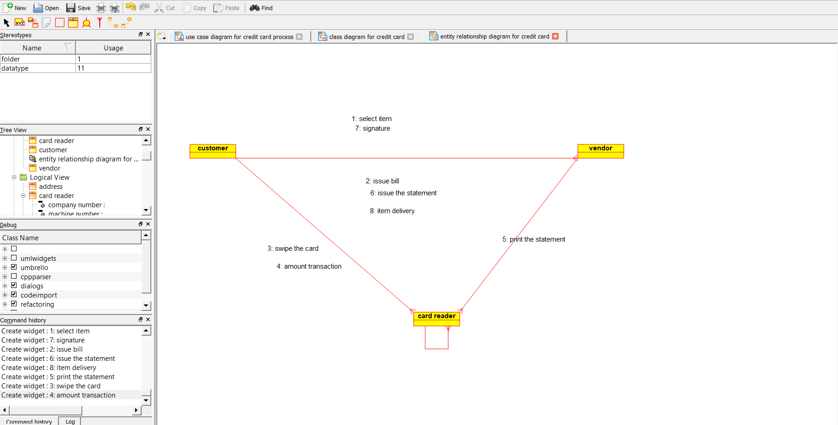

ACTIVITY DIAGRAM:

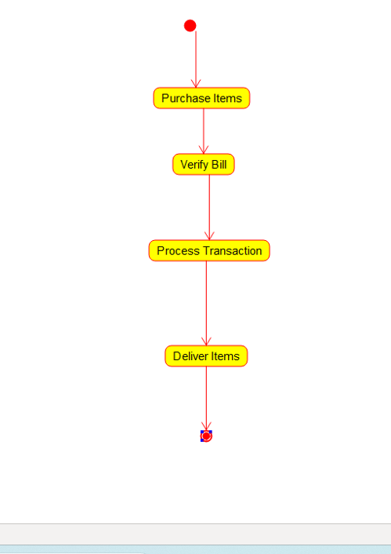

CLASS DIAGRAM:

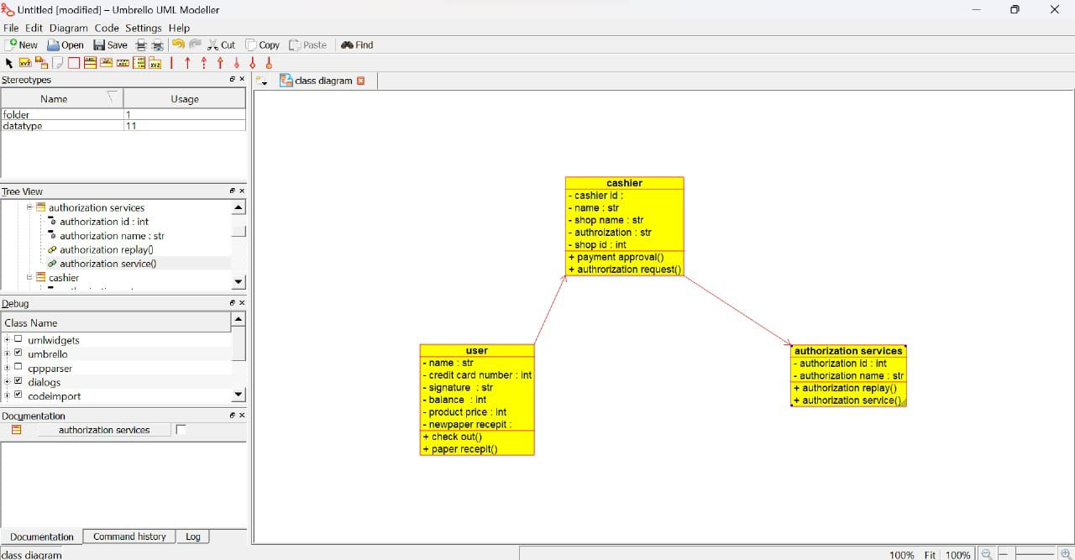

DEPLOYMENT DIAGRAM:

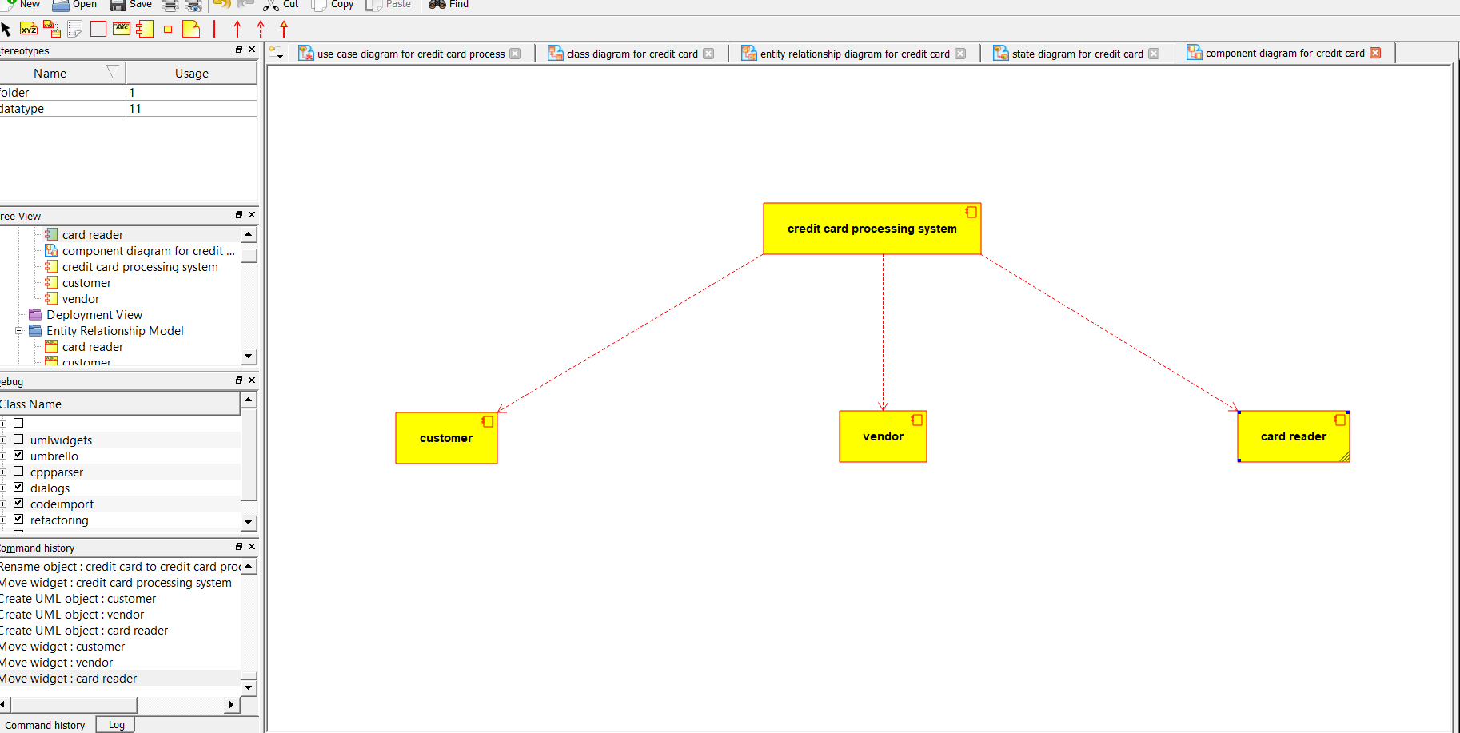

STATE DIAGRAM:

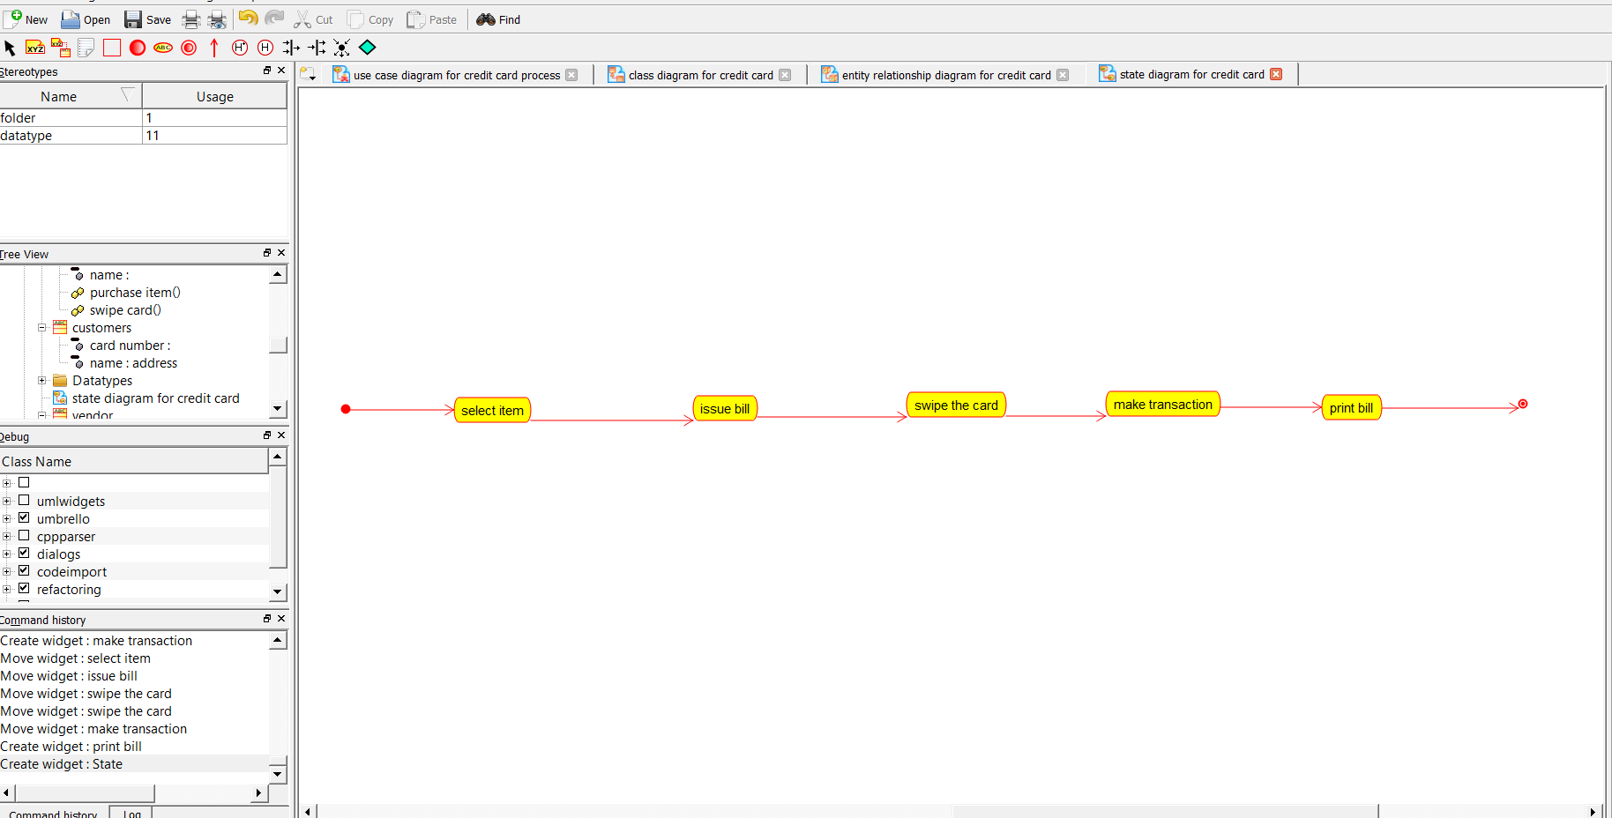

COMPONENT DIAGRAM:



USE CASE DIAGRAM:

